SECTION 1 — CREATING A GITHUB REPOSITORY

GitHub adds a social and collaborative layer on top of Git. The typical workflow: create a repository on GitHub, connect your local project, and push. Follow every step below precisely.

STEP 1 Install & Configure Git
Download Git from git-scm.com/downloads. After installation, set your global identity so every commit is attributed to you.
git config --global user.name "Your Full Name"
git config --global user.email "you@example.com"
git config --global core.editor "code --wait" # Use VS Code as editor
git config --global init.defaultBranch main # Modern default branch name
git config --global core.autocrlf true # Windows: normalize line endings
git config --global core.autocrlf input # Mac/Linux
git config --global pull.rebase true # Cleaner pull history
git config --list # Verify settings

STEP 2 Create the GitHub Repository
Method A — Web Interface:
- Go to github.com and sign in.
- Click the + icon (top-right) → "New repository".
- Enter a repository name (e.g. my-project).
- Choose Public or Private.
- Do NOT check "Add a README" if you have local files — this avoids unrelated history conflicts.
- Click "Create repository" and copy the HTTPS URL shown.

Method B — GitHub CLI (gh) — for command-line natives:
gh repo create my-project --public # Create public repo
gh repo create my-project --private --clone # Create + clone immediately
gh repo create --source=. --push # Create from current dir and push

STEP 3 Initialise Your Local Project
Open a terminal in your project folder.
mkdir my-project && cd my-project # if starting fresh
git init # initialise empty repo
echo "# My Project" > README.md
git add . # stage all files
git commit -m "Initial commit"

STEP 4 Link Remote & Push
Connect your local repository to GitHub and upload your code.
git remote add origin https://github.com/YourUsername/my-project.git
git branch -M main # rename branch to main if needed
git push -u origin main # first push; -u sets upstream tracking

# All future pushes on this branch:
git push

STEP 5 Using SSH Authentication (Recommended)
SSH keys avoid entering your password every push. The Ed25519 algorithm is recommended for security and performance over legacy RSA.
ssh-keygen -t ed25519 -C "you@example.com" # generate key pair
eval "$(ssh-agent -s)" # start the agent
ssh-add ~/.ssh/id_ed25519 # add key to agent
cat ~/.ssh/id_ed25519.pub # copy this to GitHub Settings → SSH Keys
ssh -T git@github.com # verify connection

# Then switch your remote to SSH:
git remote set-url origin git@github.com:YourUsername/my-project.git
💡 Tip: SSH is more secure and eliminates password prompts on every push.

STEP 6 Personal Access Tokens (PAT)
For HTTPS connections, GitHub requires a PAT (password-based access was deprecated in 2021). Two types:
- Classic Tokens: Broad API keys with scopes (e.g., repo, workflow). Easier to set up.
- Fine-Grained Tokens (Recommended): Limit access to specific repositories and specific permissions (e.g., Read-only Issues, Write Content). Implements the principle of least privilege.

SECTION 2 — Git Settings and How I used Git to push my file to Github with screenshot

STEP 1 Install & Configure Git
Download Git from git-scm.com/downloads. After installation, set your global identity so every commit is attributed to you.
- Go to the folder where the document is placed that you want to push to Github. 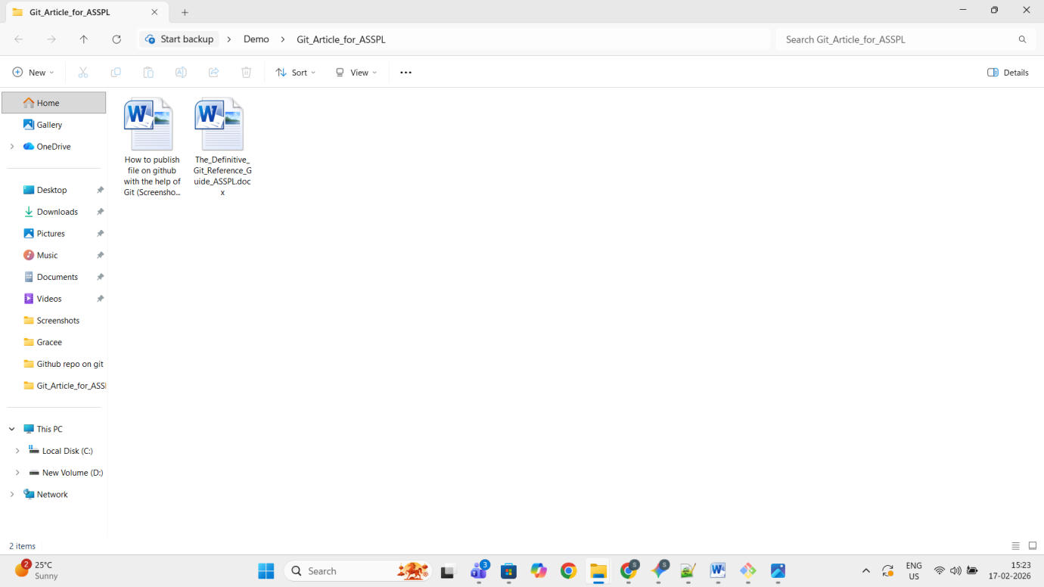
- Inside the folder, to open git bash here do as shown in the image: 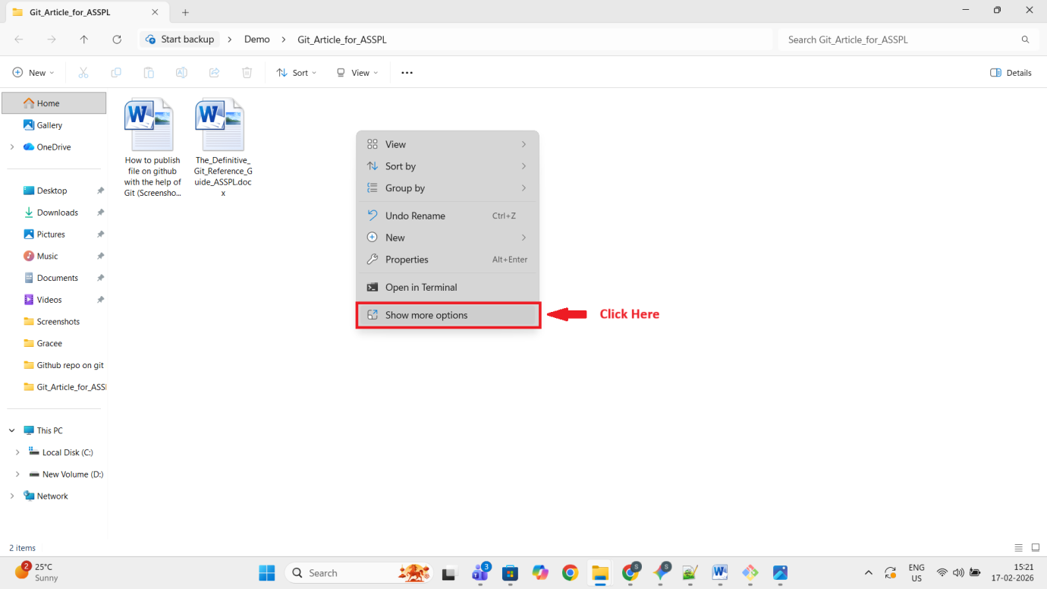 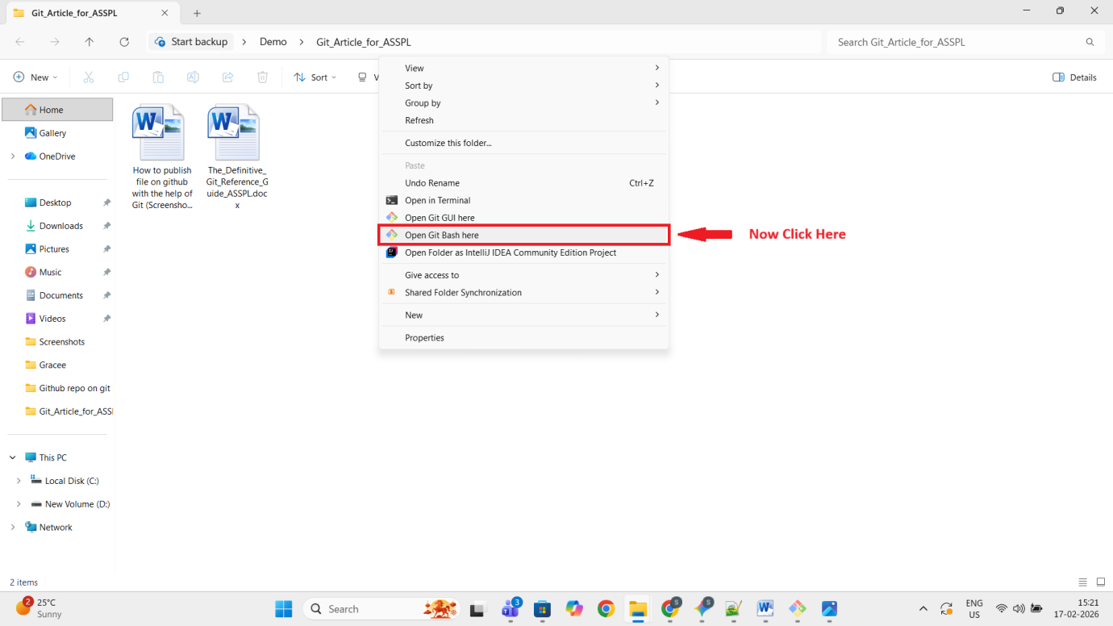
- You should see the below screen: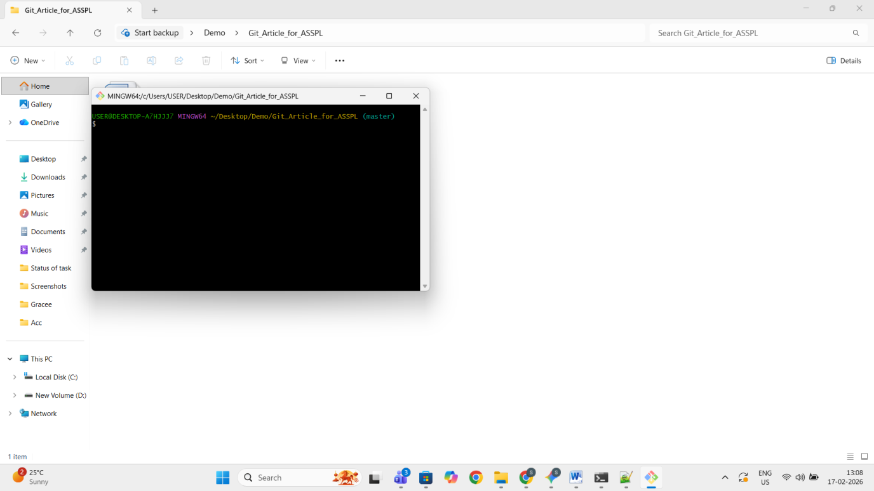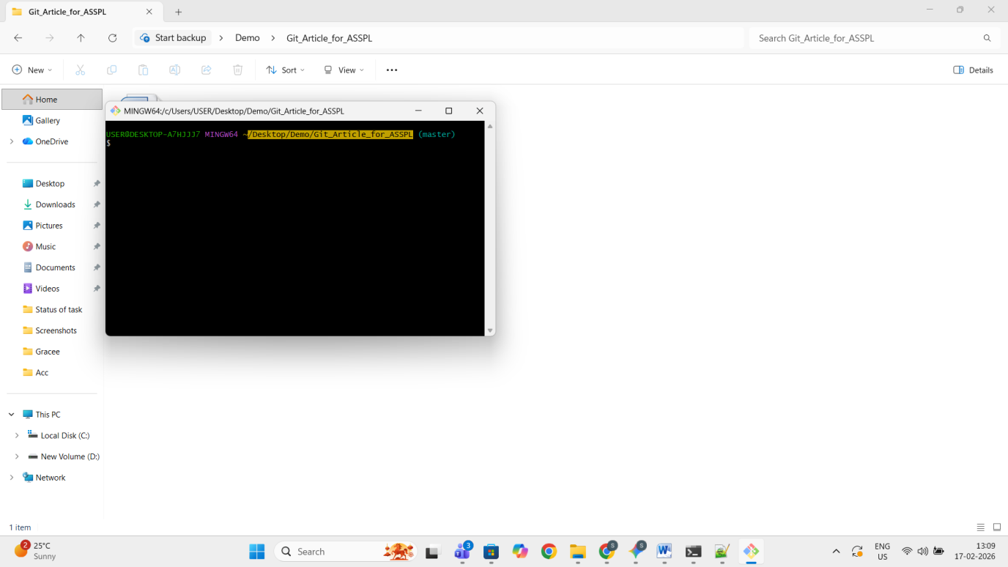
- Type the following command:
git config --global user.name "Your Full Name"
git config --global user.email you@example.com 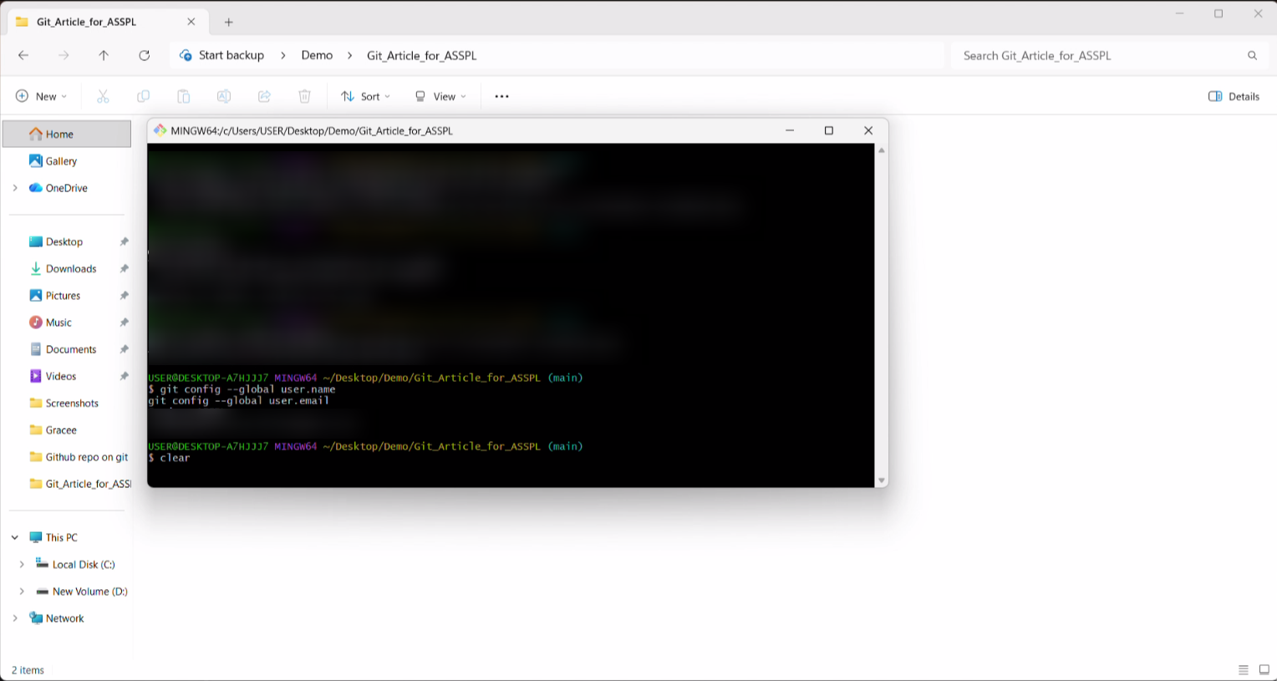
- The user name and email will show here
- Now initialize the project: git init 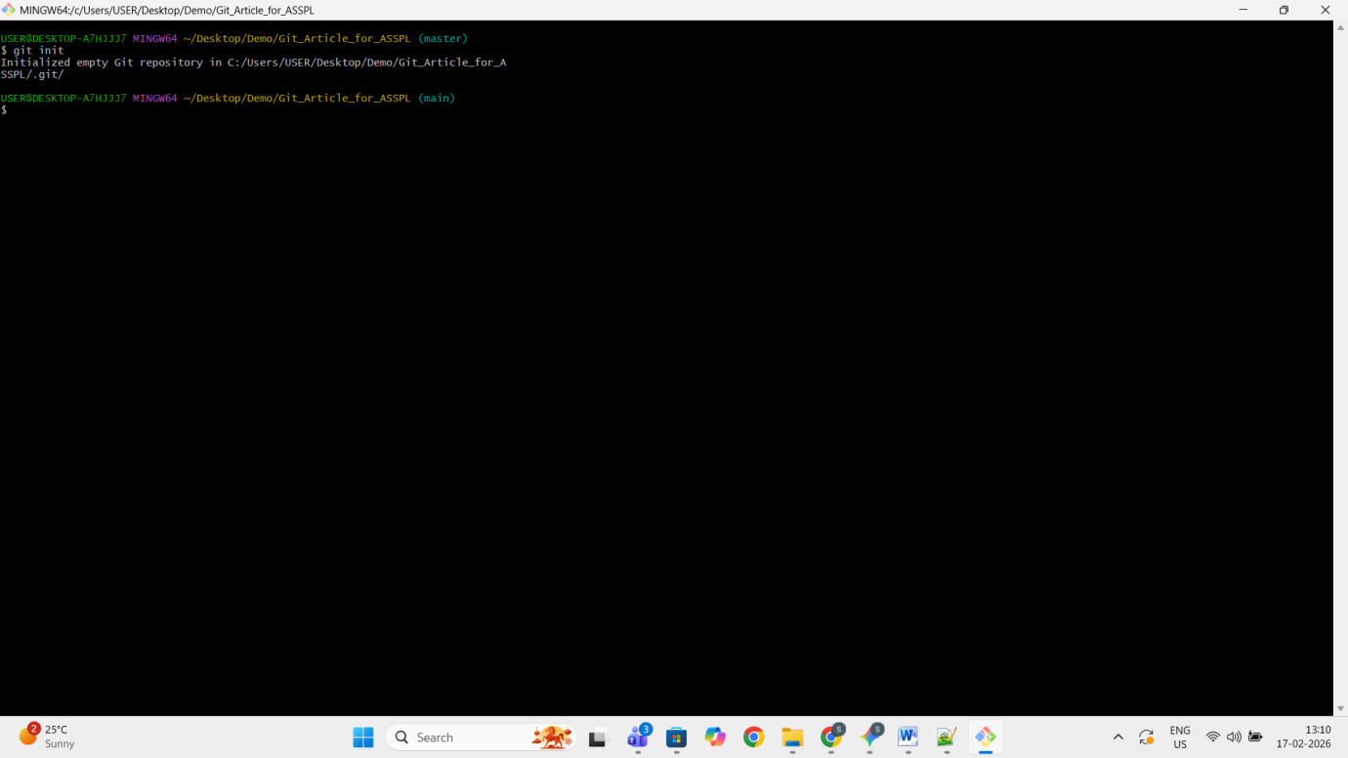
- Write command to list all the files and folders present inside: ls -al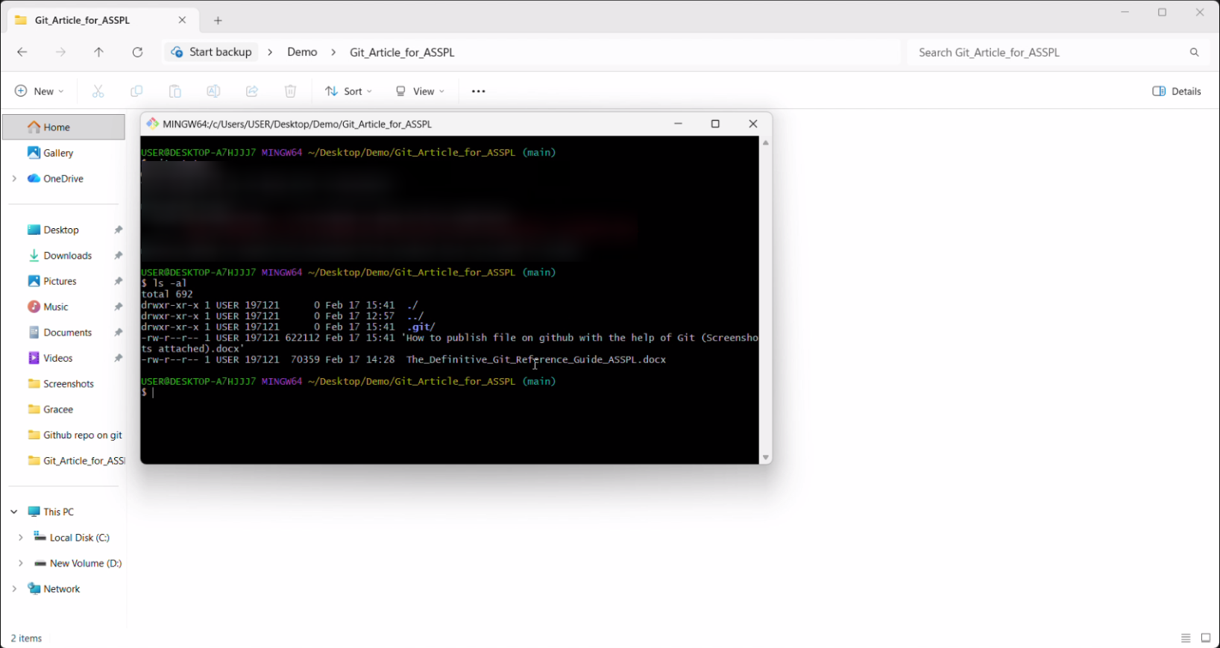
- Check status: git status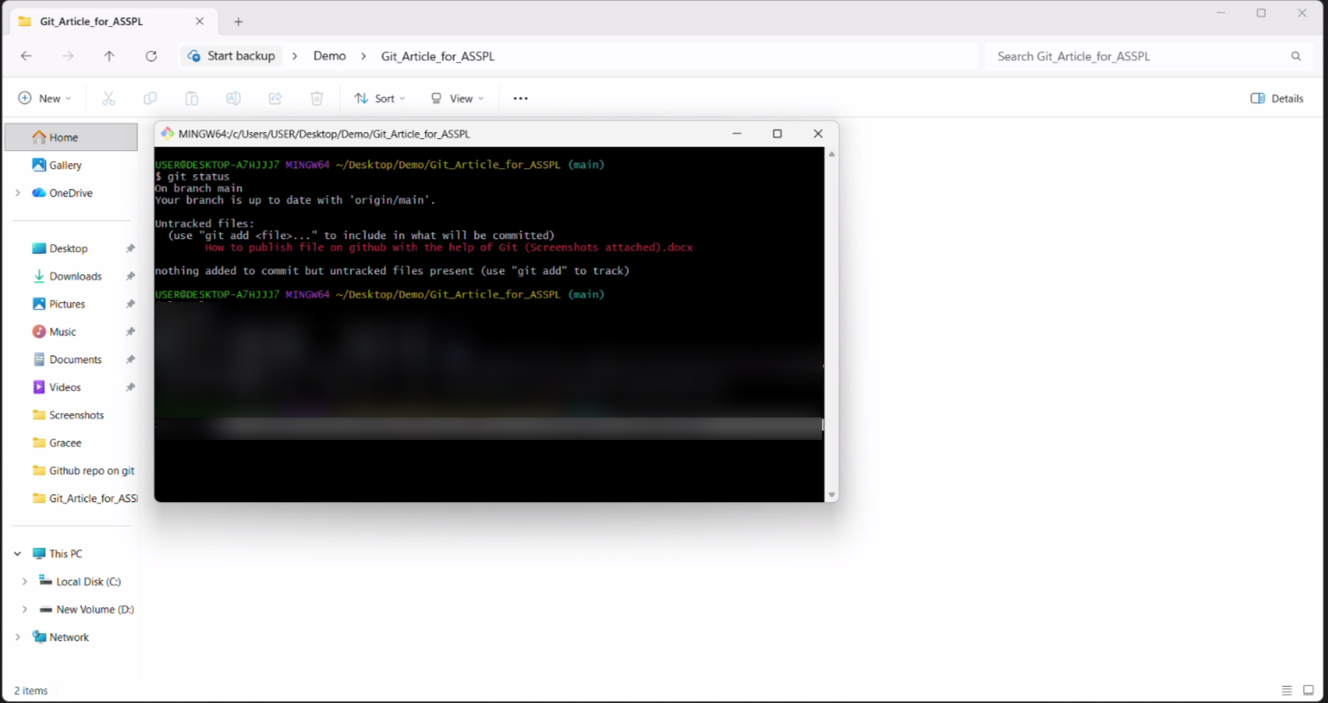
- As in here you can see nothing is added to commit
- Add the file you want to commit by: git add “file name” 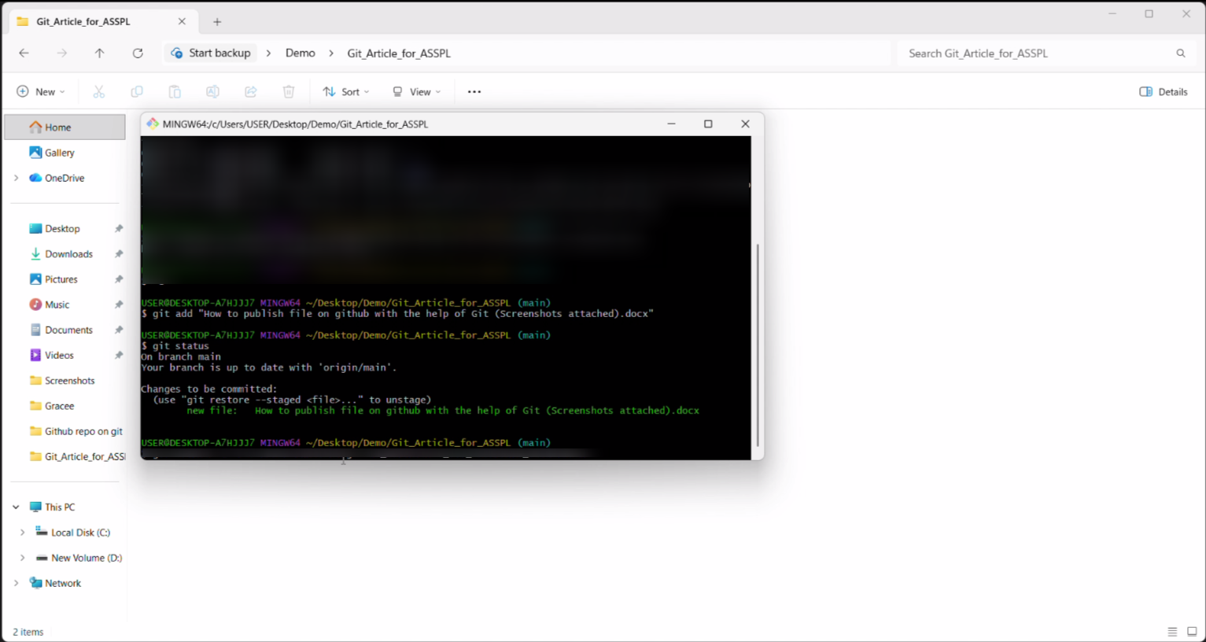
- Now type git status once now you will see the file you want to commit in green color text as in the image
- Commit the file with this code: git commit –m “any comment” 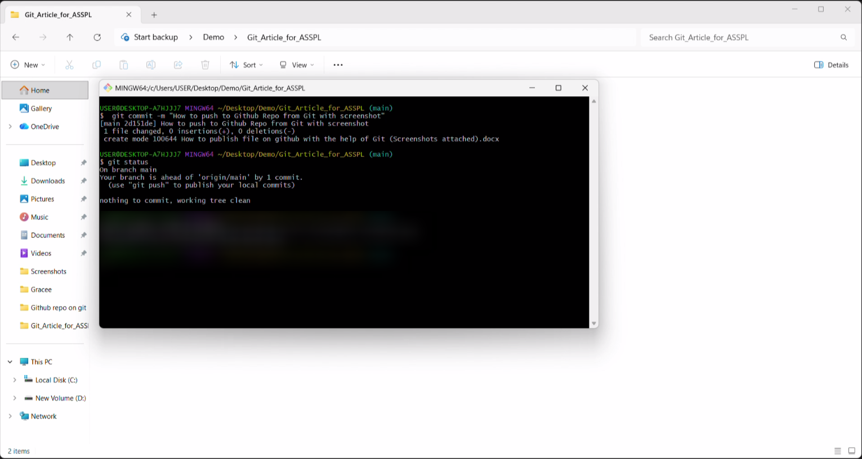
- If the commit is successful after git status, it will tell nothing to commit
- Ifyou want to check the names of the files committed: git ls-tree --name-only HEAD 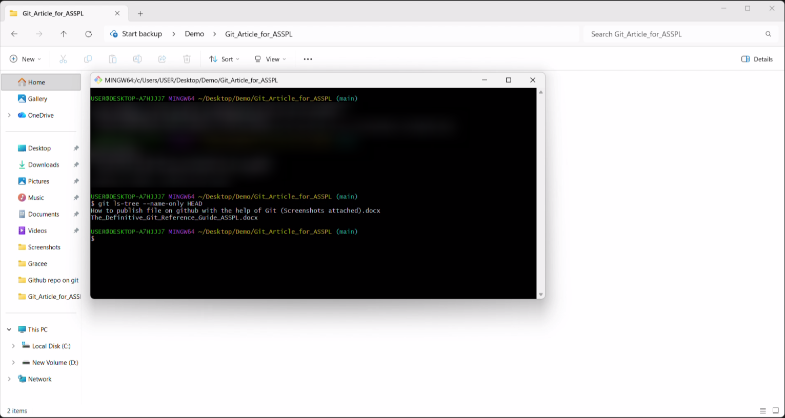

STEP 2 Create the GitHub Repository
Method A — Web Interface:
- Go to github.com and sign in.
- Click the + icon (top-right) → "New repository".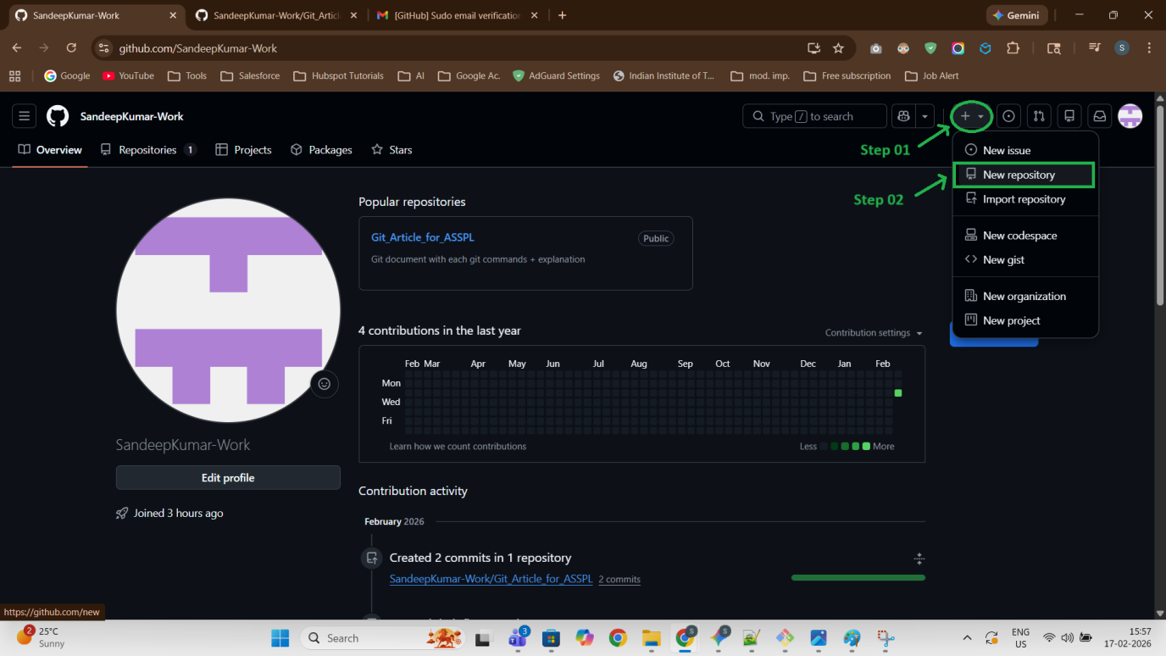
- Enter a repository name (e.g. my-project).
- Choose Public or Private.
- Do NOT check "Add a README" if you have local files — this avoids unrelated history conflicts.
- 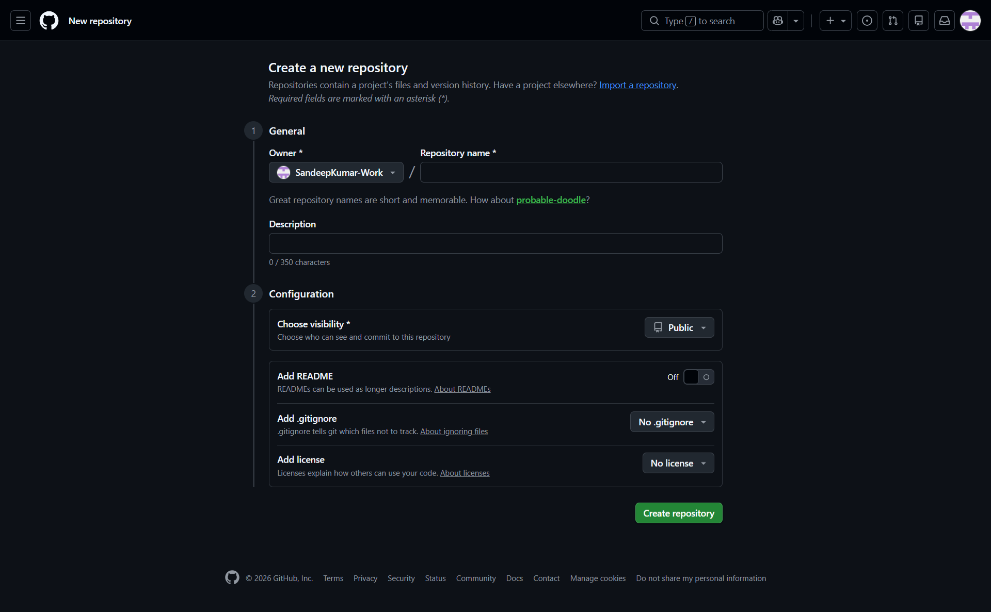
- Click "Create repository" and copy the HTTPS URL shown.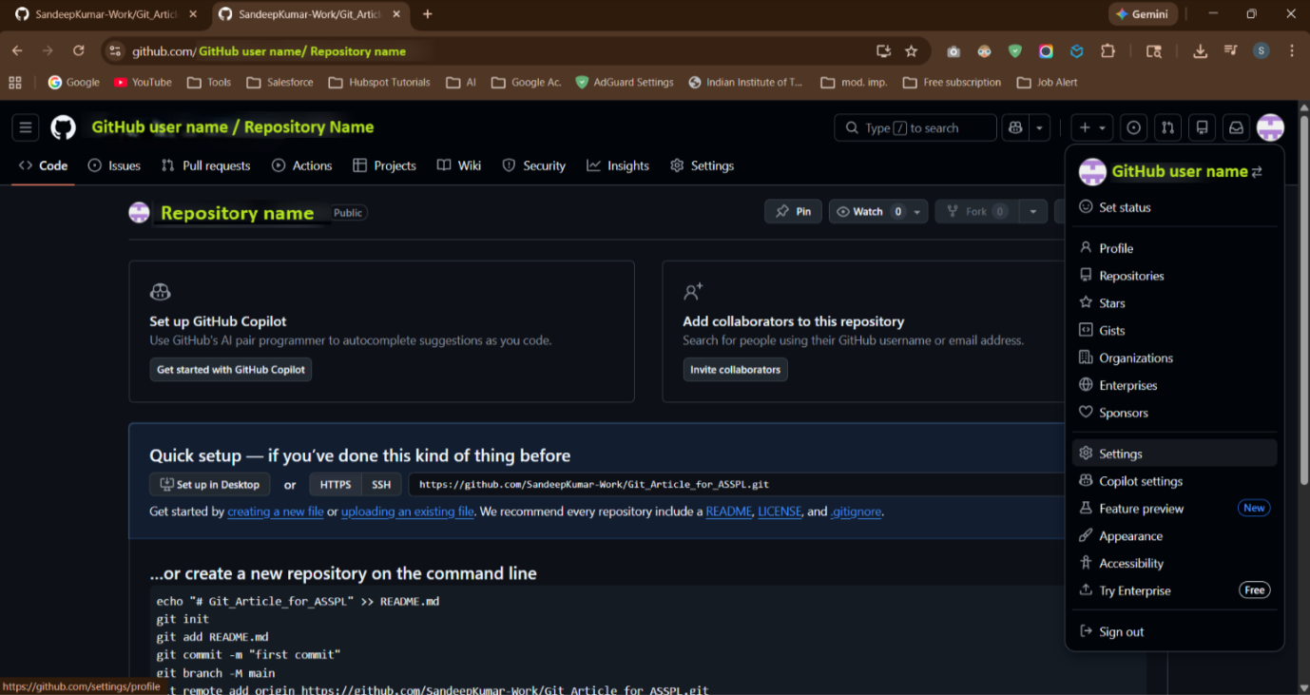

STEP 3 Personal Access Tokens (PAT)
I have used the classic token
- Click on the profile, and the click settings
- Scroll to the bottom till you see Developer settings options in the left side bottom: 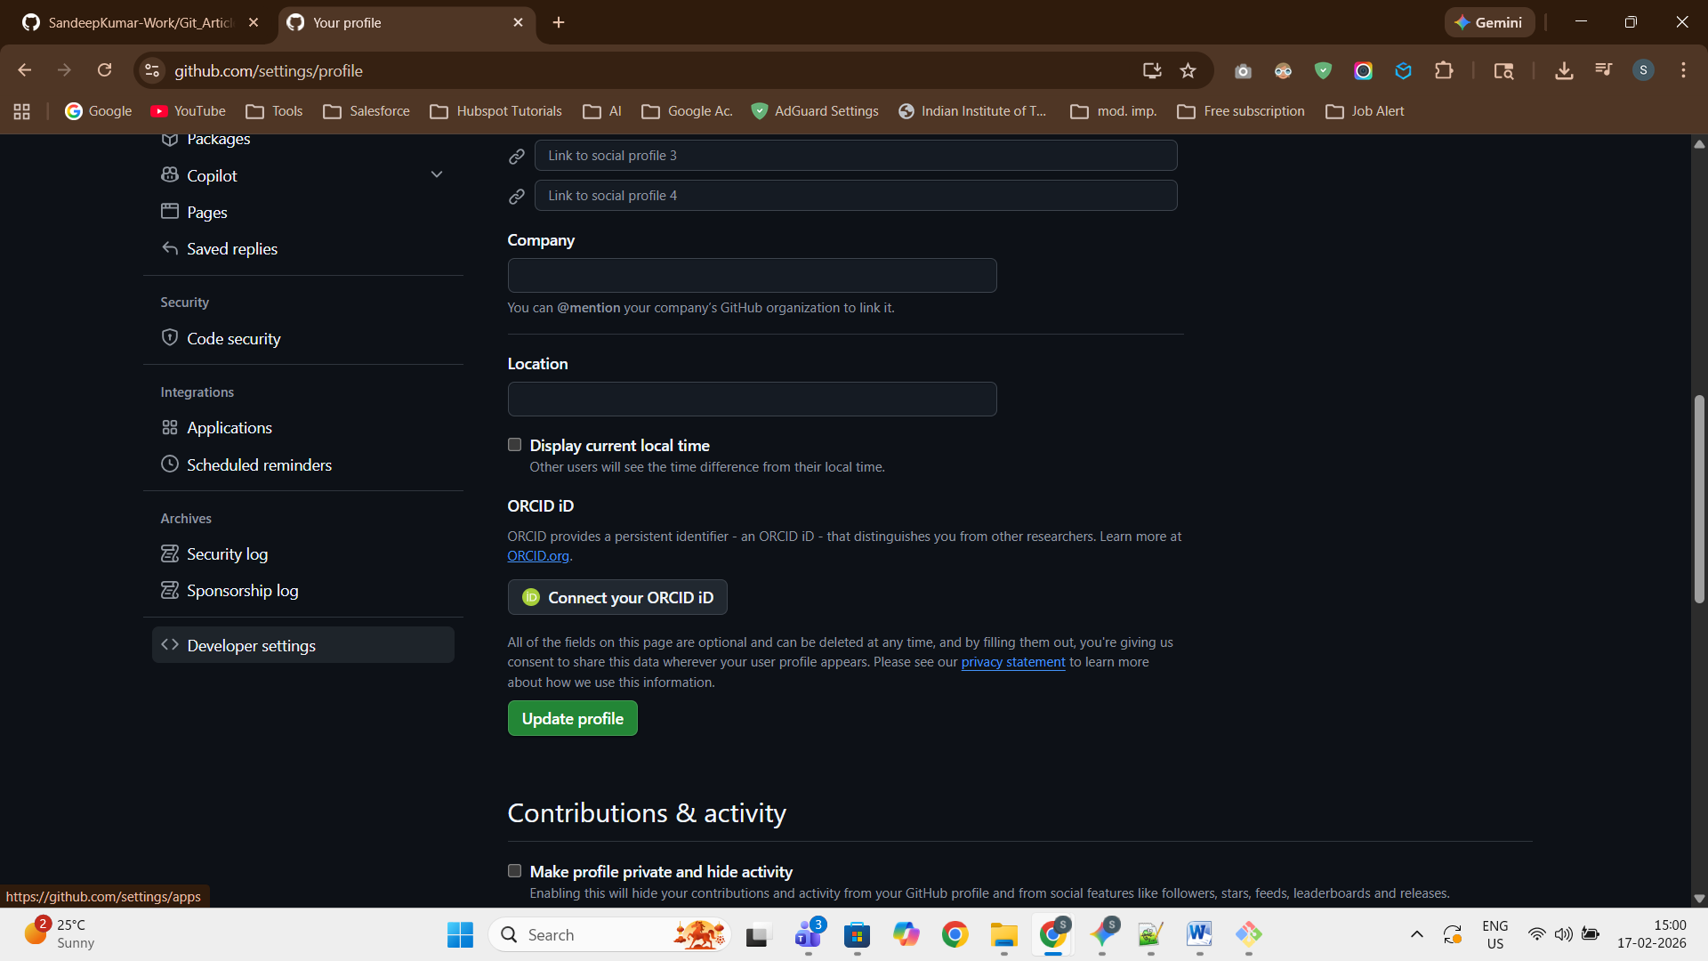
- Then click the Personal Access tokens and then select token (classic). 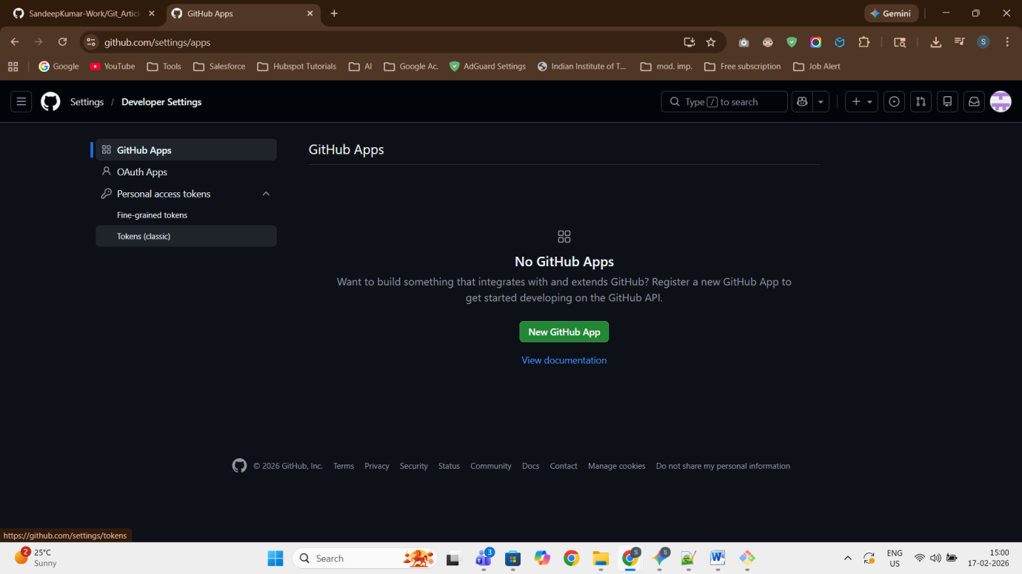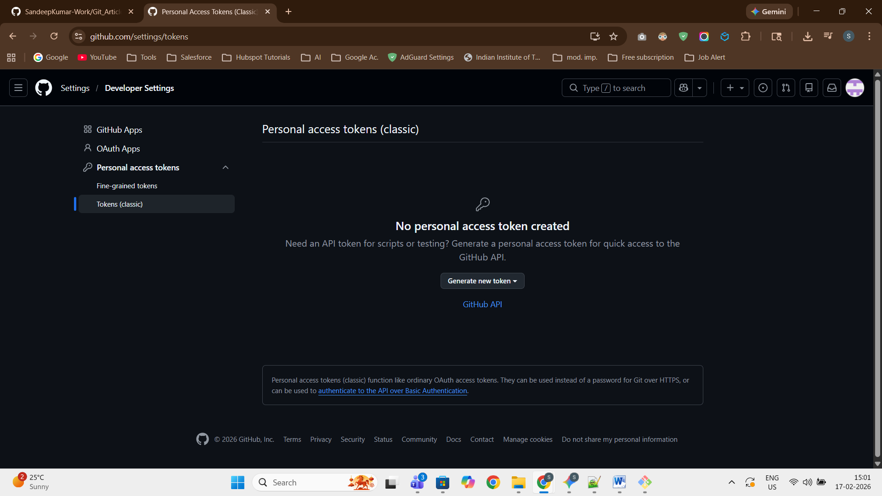
- Then Create the generate new token option (in my case it is in the centre as I don’t have any available PAT), the select Generate new token (classic) 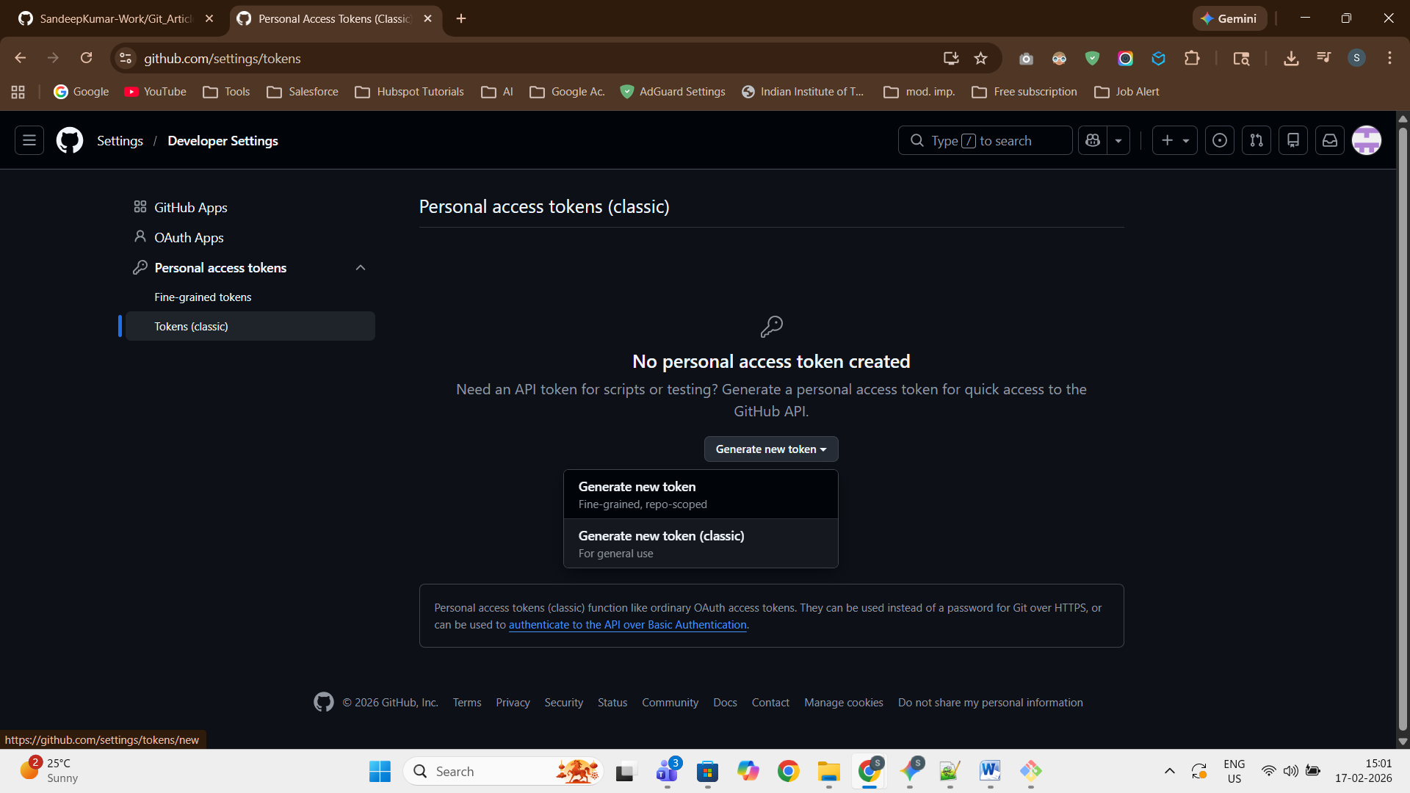
- Then give the name and permission to the PAT that you want to give. Also set the validation period of the token according to your needs.
NOTE: Make sure you copy the generated token to a notepad as once youclose it you will not be able to access the page again

STEP 4 Link Remote & Push
Connect your local repository to GitHub and upload your code.
- Go to git bash inside the project again then type this code:
git remote add origin https://PTA@github.com/YourUsername/RepositoryName
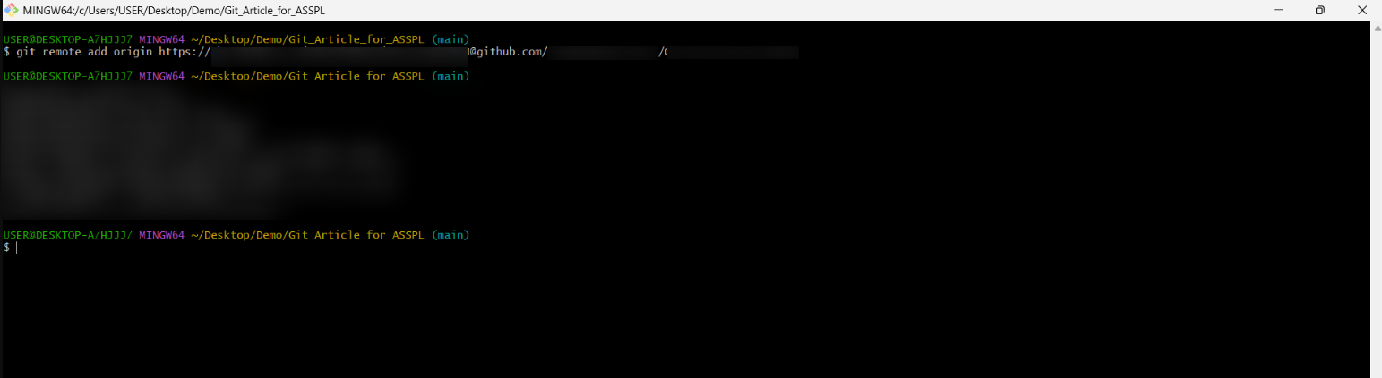
- Then type:
git branch -M main # rename branch to main if needed
in my case I don’t need this step
- Next inside Git bash type:
git push -u origin main # first push; -u sets upstream tracking
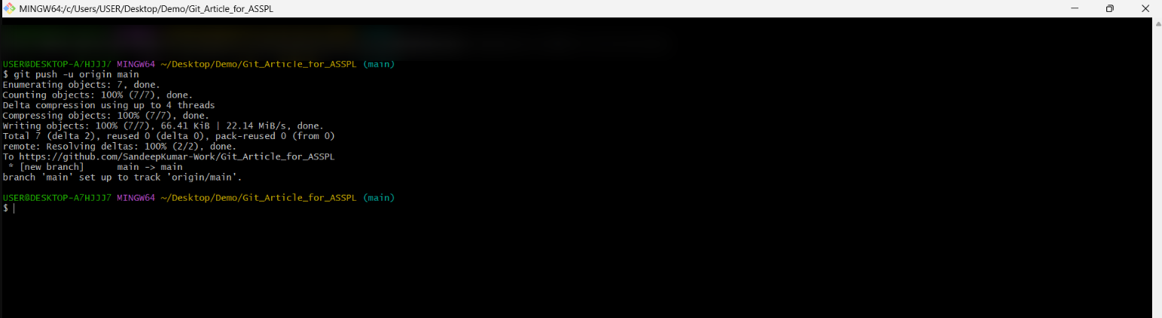
- Done your project files should appear in your GitHub Repository

